KORE Custom Table Uploader Guide

Version 2.1
07/01/2019

Contents
Accessing Custom Table Uploader 3
Creating Your Table 4
Populating Tables 7

Accessing Custom Table Uploader
- Go to configuration records

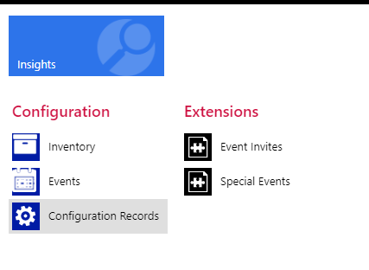
- Under DWA select Custom Tables

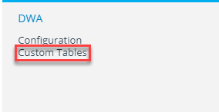

- Select the create new option that is at the top left of your screen

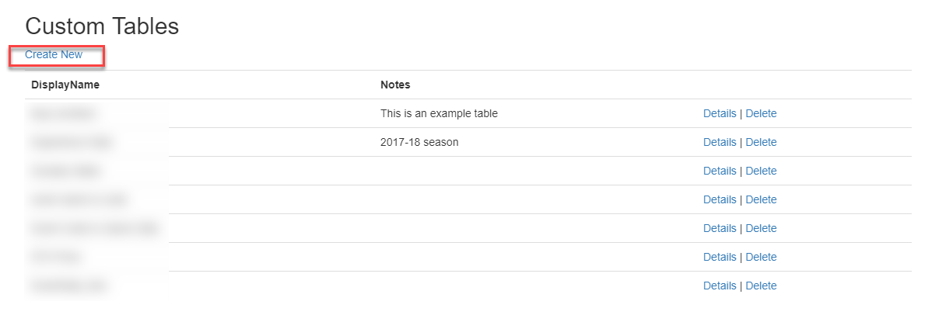

Creating Your Table
- In display name enter the name of your table that will live in CRM.
- Next in name enter the name of your table that will live in aginity (no spaces or special characters with the exception of _ ).
- Similarly, Notes will also only live in CRM. Our recommendation is to enter the date you last updated the table.
- Select Choose File and select the file you would like to upload.
- Next select Header Row if the file you are loading contains a header row.
- One chosen select Suggest Columns, this should create your columns for you.
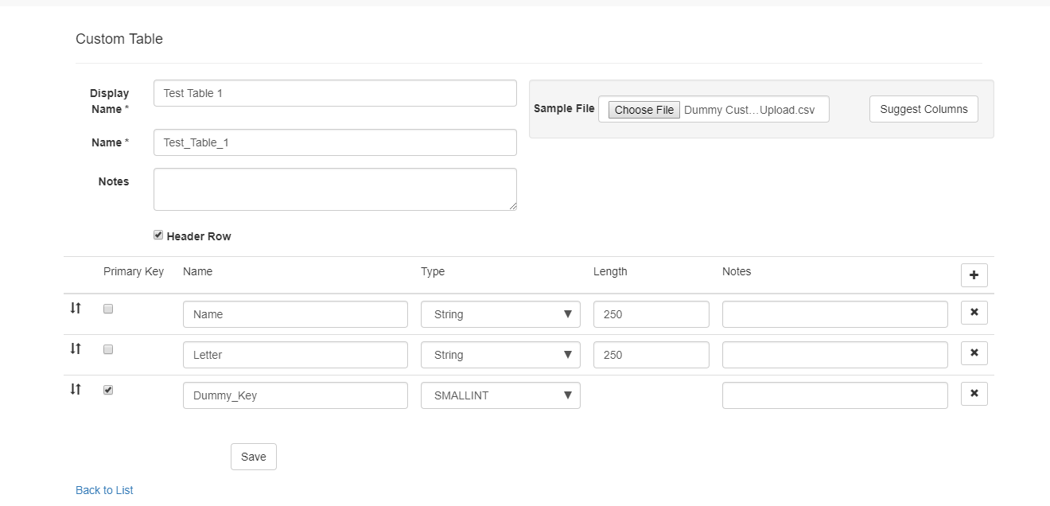

- If you had selected Header Row the name of your columns should have pre-populated when you selected Suggest Columns.
- If you did not select Header Rows you will need to fill in the name of your rows.

- To the left of Name is Primary Key. You will need to select a unique column as the primary key. Although aginity does not follow standard key rules, a primary key is necessary to prevent duplicates. If the primary key is not unique the file will not load and the will show an error.

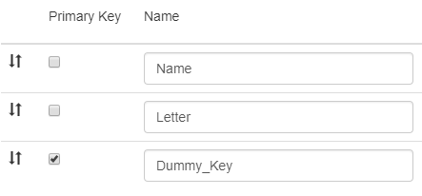

- Following this you will need to select what type of field each row is. The custom table uploader does not work well with date fields therefore, we recommend using a string field instead.
  - Field Types:
    - BIGINT: An integer with up to 19 digits (no decimal)
    - BOOLEAN: Stores TRUE or FALSE values
    - Date: Stores year, month, and day values
    - Date & Time: Stores year, month, day, hour, minute, and second values
    - Decimal: Exact number (Ex. Decimal(5,2) is a number that has 3 digits before the decimal and 2 digits after the decimal)
    - INTEGER: An integer with up to 10 digits (no decimal)
    - SMALLINT: An integer with up to 5 digits (no decimal)
    - String: Character string with variable length. Must specify maximum length.
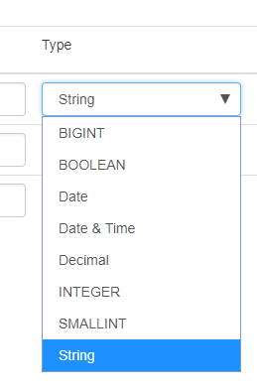
- Select Save

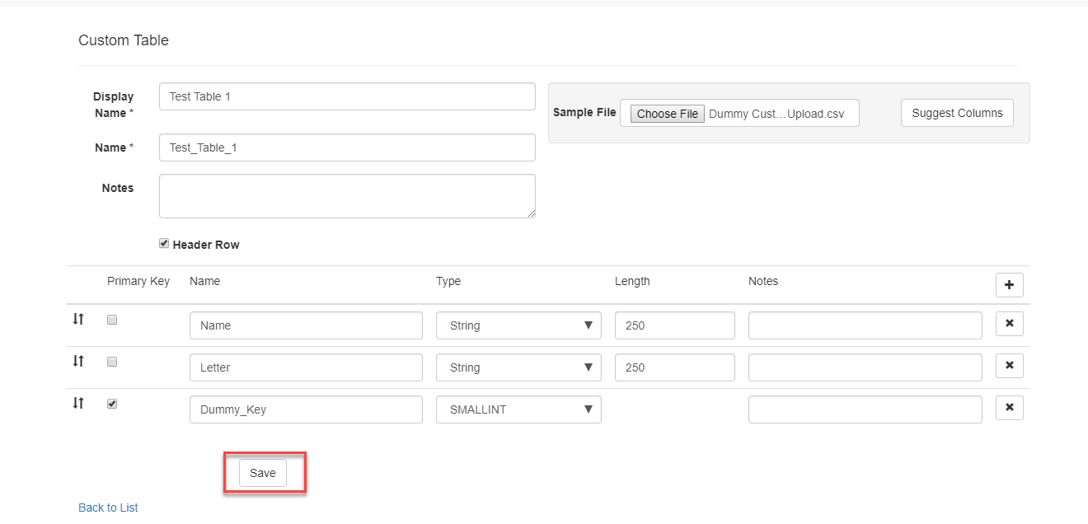

- You will then be taken back to the original Custom Tables Page where your new table should have been added.
- If you look under the custom schema in redshift the new table should have been created there as well. (You will not be able to change the row names through CRM, all changes must be done through your chosen database administration tool.)
- To Delete the table simply select delete next to the respective table you wish to delete. (This will delete the table in both CRM and Redshift)
- If you make a mistake in this process the best option will be to delete the table and re-upload it.

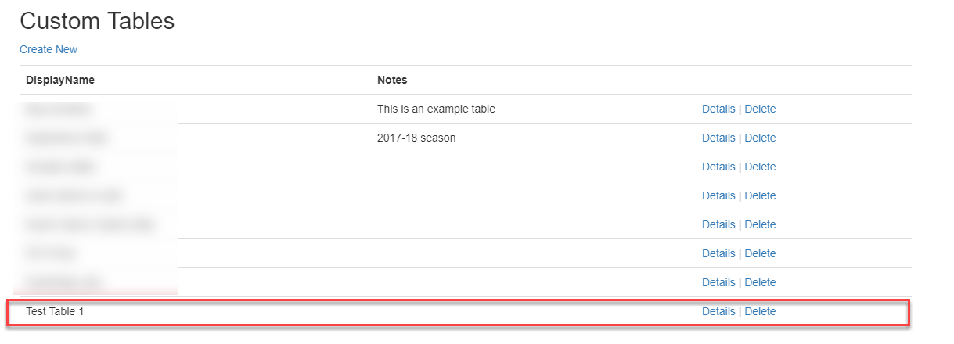

Populating Tables
- Select the Details option that is next to the delete

- You will be taken to a details page where you will have the following options: upload, export, and advanced.
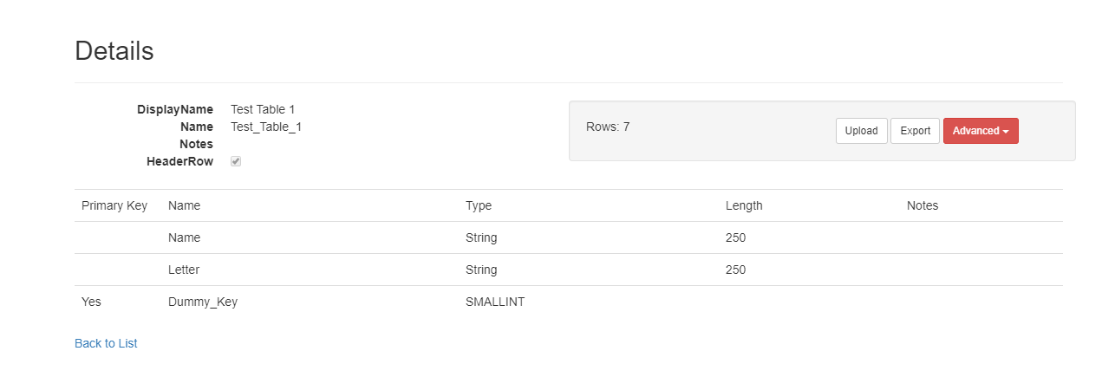
- Export will allow you to export the data already in the table into a CSV file.
- Advanced will allow you to rename the table or truncate the data (deletes the rows, but keeps the table structure).
- To continue populating the table, select Upload.

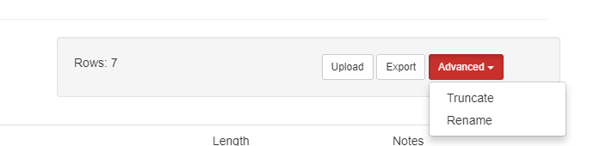

- You will be directed to a new page where you will need to select Choose File.
- At this point you will need to upload the original file you had you used to create the table.
- Make sure to check the Has Header Row box if you have a header row in the file.
- Once you have selected your file, select Upload Files.
- Wait until the results come back as File Uploaded Successfully and the load bar changes from blue to green and is showing 100%.

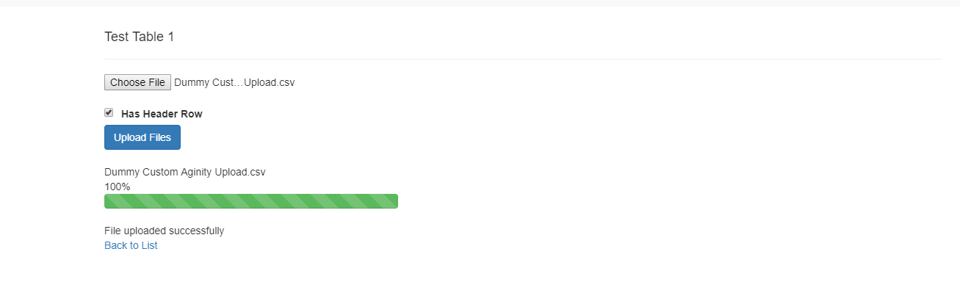
- You may use the same process to update the table when you would like to add/remove rows.
- You should now see the table in aginity and be able to query through the table you have uploaded.

