Adding Tableau Workbook to CRM

11/12/2018
- Publish workbook onto Tableau Server
The first step would be to publish the workbook onto KORE's Tableau server (https://bi.koresoftware.com) in the Client folder. You can use any of the three highlighted folders based on the module(s) you have.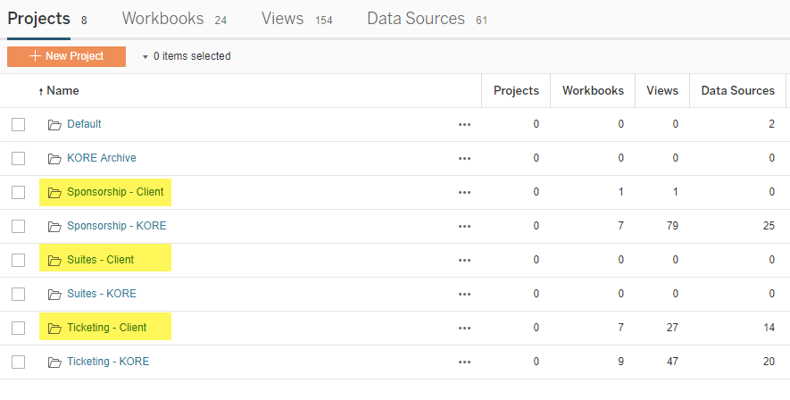
- Set necessary permissions to Client folder on Tableau server
Once the workbooks have been published to the Tableau server in the Client folder, you’ll have to set the appropriate permissions for that folder. To do so, follow these steps:
  - Click on the checkbox next to the folder
  - Hit ‘Actions’ and then ‘Permissions’
  - Add the appropriate groups by clicking on ‘Add a user or group rule’ on the new window, as indicated by the green arrow
  - The suggested permission for Managers/Reps to Tableau projects, workbooks and data sources is Viewer, Interactor and Connector but this can be changed for the Client folder based on your requirements. To see what each of these permissions mean, you can expand the view as shown by the yellow arrows.
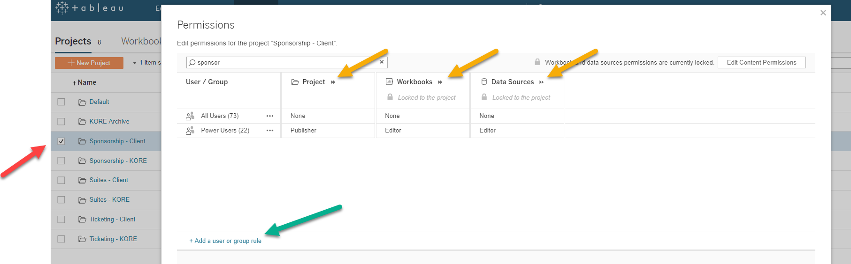

- Find which Tableau space to utilize inside Dynamics
  - Our solution comes with 30 Tableau slots which can be used to link a web resource created in Dynamics to a Tableau workbook.
  - Go to Configuration Records → Tableau (in KORE section) and you'll see 30 slots like 'Sponsorship Workbook 1 View', 'Suites Workbook 1 View', 'Ticketing Workbook 1 View' etc.
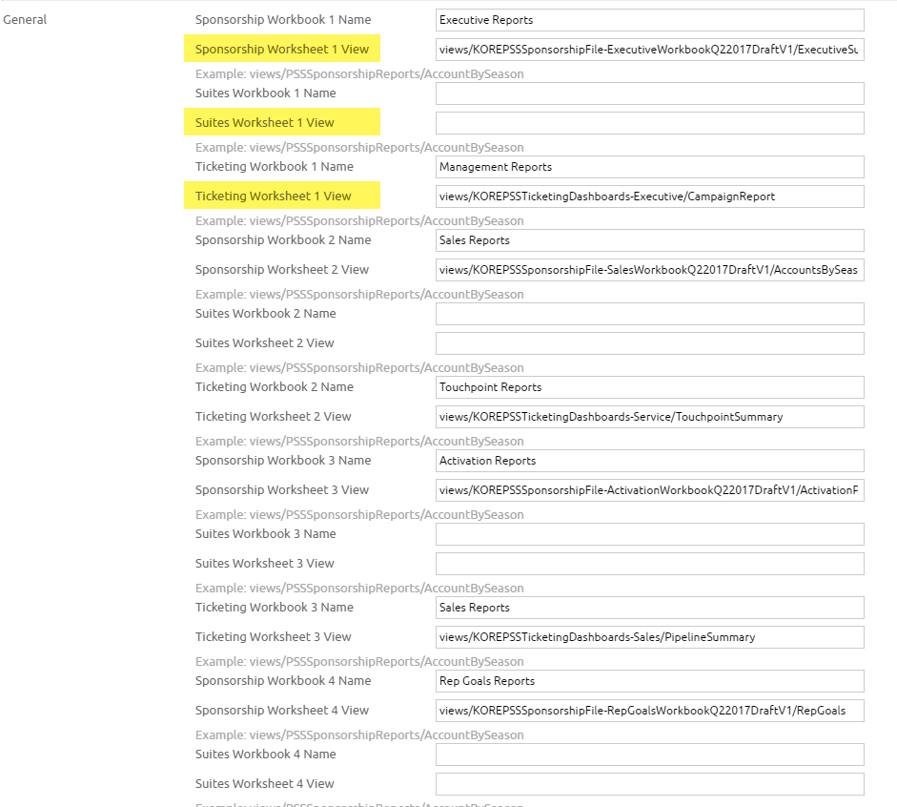
  - Some of these slots will be pre-populated with the standard Tableau workbooks but you can use any unutilized slots to link the custom Tableau report to the CRM. Scroll to the bottom and you'll see most of the slots are unpopulated.
  - As a general rule of thumb, if the Tableau workbook is for the Sponsorship module pick the 'Sponsorship Workbook 10 View' slot and work backward.
- Link Tableau workbook to Tableau slot in Dynamics
  - Once you've figured out the slot (let's say the 'Sponsorship Workbook 10 View'), copy the URL of the view from Tableau server workbook into the 'Sponsorship Workbook 10 View' slot as shown below:
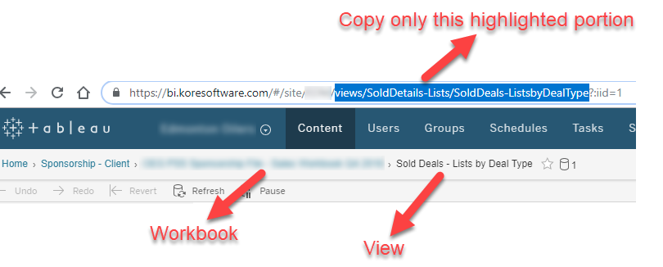
  - Name the workbook as you desire in the 'Sponsorship Workbook 10 Name' slot
  - Scroll down to the bottom of the page and hit 'Save'
- Create a New Web Resource in Dynamics
  - Go to Settings → Customize The System → Web Resources → New
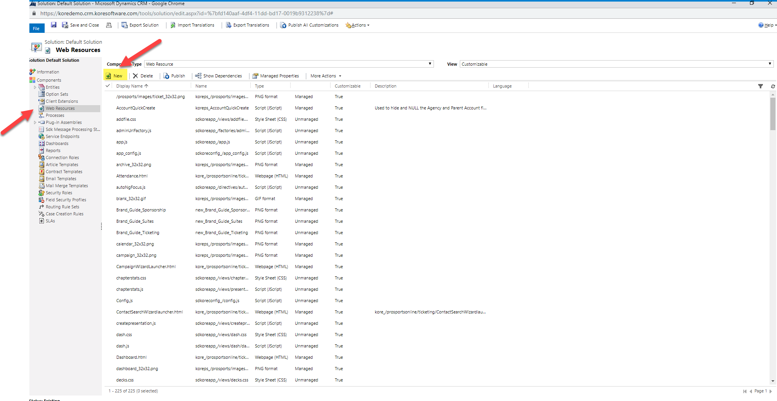
  - Under the General tab, fill in the following information:
    - Name: new_TableauSponsorship10 (the "new_" should already exist)
    - Display Name: Tableau Sponsorship Workbook 10

  - For 'Type' under Content, choose "Webpage (HTML)"
  - At this point, the window should look like this
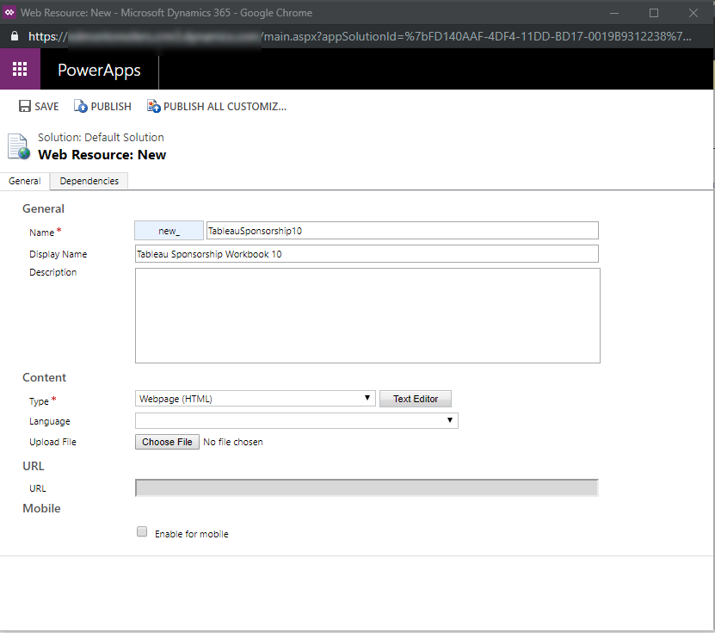
  - Hit 'Text Editor', navigate to the 'Source' tab and copy this code:
<html><head><meta charset="utf-8"><meta><meta><meta><meta><meta><meta><meta><meta><meta><meta><meta><meta><meta><meta><meta><meta><meta><meta></head><body style="word-wrap: break-word;">
<script src="ClientGlobalContext.js.aspx" type="text/javascript"></script>
<script src="kore_/prosports/scripts/jquery.min.js" type="text/javascript"></script>
<script src="kore_/prosports/scripts/crmhelper.js" type="text/javascript"></script>
<iframe id="iframe1" noresize="noresize" width="100%" frameborder="0"></iframe>
<script type="text/javascript">
var user = Xrm.Page.context.getUserId();
var url = Kore.Crm.getKOREServerOnlineBaseUrl();
var org = Kore.Crm.getKOREServerOnlineOrganization();
var token = Kore.Crm.getKORESecurityToken();
document.getElementById('iframe1').src = url + "/common/Dashboards/Tableau.ashx?Type=1&workbook=10&orgname=" + org + "&userid=" + user + "&token=" + token;
document.getElementById('iframe1').height = window.innerHeight - 50;
</script></body></html>
The only thing that might need to be changed is the text highlighted in red "Type=1&workbook=10". This denotes the slot used in Step 3. Type denotes module (1=Sponsorship, 2=Suites, 3=Ticketing) and workbook denotes the slot no. used in this module. For eg - If you were to use the "Ticketing Workbook 8 View" slot, this code would be changed to "Type=3&workbook=8".
  - Hit 'OK' once you're done and you'll see the URL populate automatically on the web resource window. To check if the web resource is now linked to the Tableau workbook, click on the URL and a preview will appear. If nothing shows up, please re-read the steps and make sure all the configurations have been setup correctly.
  - Hit 'Save' and 'Publish'
- Embed the Web Resource onto the Site Map
If you have the 'Sitemap Designer', use steps below ELSE use the other document attached.
  - Go to Settings → Customize The System → Client Extensions. Double-click on 'Site Map' and the 'Sitemap Designer' will open up in a new window.
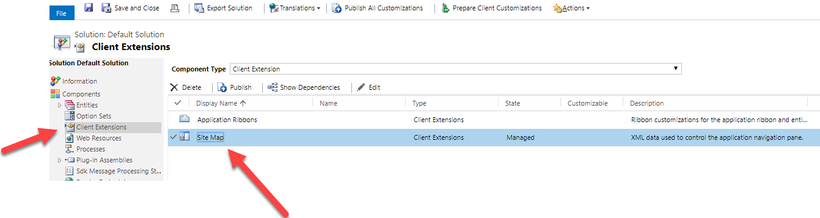
  - Drag a Subarea from the 'Components' section on the right to the required space on the Site Map. This Subarea will contain the new Tableau workbook.
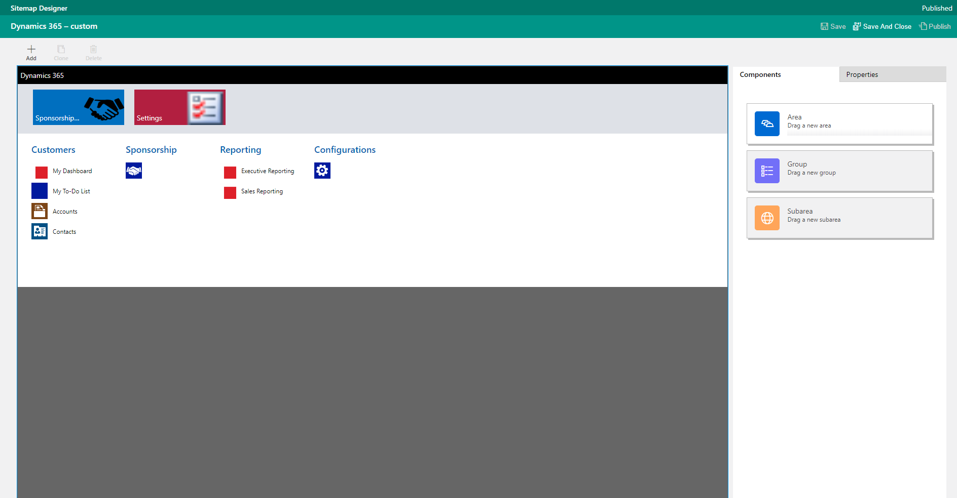
  - To configure this 'New Subarea' navigate to the 'Properties' section and enter the following information:
    - Type: Web Resource
    - URL: This will be the display name entered in Step 4 (b)
    - Title: Enter what you would like this tile to be called
    - Icon: You can use the same icon as the other tiles
    - Expand 'Advanced' and 'Privileges' and under Entity, select "System Component PSStandard Sponsorship/Ticketing/Premium Sales Access" based on what module is being used.
    - Hit 'Save' and ‘Publish’

